To mark the 25th anniversary of the fall of the Berlin Wall, the German Embassy is presenting an exhibition of Berlin art at the German House, 34 Belgrave Square in London. After an exclusive preview event in early November, this exhibition, entitled “East meets West: Bringing down the Wall” will be on public view during an Open Day on 12 November from 9:00 am to 9:00 pm.
There are also useful websites with information about the events from 25 years ago.
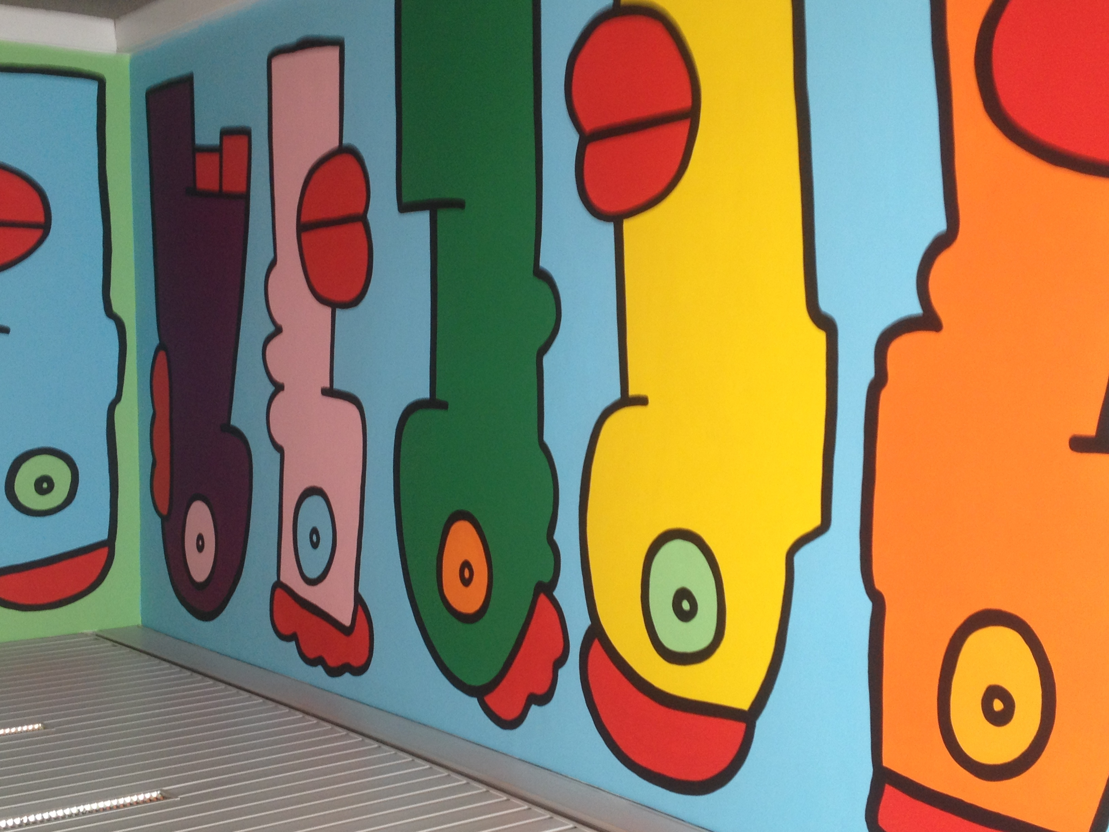
http://www.london.diplo.de/Vertretung/london/en/__pr/Embassy__Events/11/Panel-Discussion.html

http://www.london.diplo.de/Vertretung/london/en/09/13-Berlin-Wall/__25-Years-Fall-of-Berlin-Wall.html

