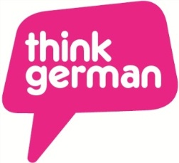
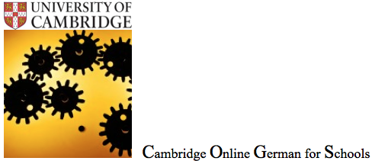
Saturday 13 June 2015
11am – 4.30pm
Murray Edwards College, Cambridge

GERMAN – ENGLISH
ENGLISH – GERMAN
TRANSLATION
Cambridge Online German for Schools
Department of German and Dutch
Cambridge German Network
Registration for Schools (attendance for school students and their teachers is free of charge) All registrations must be received by 15 May 2015 latest.
Please note that all pupils must be accompanied by a teacher.
Owing to the limited number of places available we may not be able to accommodate all schools and may limit the number of pupils per school. We will confirm allocated places in time before the event.
NAME OF SCHOOL

SCHOOL TOWN & POSTCODE
NAME & ROLE OF ACCOMPANYING TEACHER(S)

TEACHER’S EMAIL ADDRESS(ES)
STUDENT NAMES (please indicate if under 18 at the time of the event)
PLEASE NOTE that the event will be captured via images and/or audio/video recording which may include some under-18s. For any pupil registered, we assume that permission has been given for the Faculty of Modern and Medieval Languages to use these images and recordings on our website, in our brochures or leaflets and in press releases.

PLEASE RETURN THIS FORM VIA EMAIL TO german@mml.cam.ac.uk

